**Team 7**

**Ratheeban Rajakumar**

**Yves Chapuis**

**Roman Alonzo**

**Roland Tschendel**

**Michael Monteiro**

**Software Requirements Specification**

**Document**

**Version: (2.0)** **Date: (12/12/17)**

Content

1. Introduction 3

1.1 Purpose 3

1.2 Scope 3

1.3 System Overview 3

1.4 Stakeholders 3

1.5 Definitions 3

2. The Overall Description 3

2.1 Product Perspective 4

2.1.2 System Interfaces 4

2.1.3 User Interfaces 4

2.1.5 Software Interfaces 5

2.1.6 Communications Interfaces 5

2.1.7 Memory Constraints 5

2.2 Design Constraints 5

2.2.1 Operations 5

2.2.2 Standards Compliance 5

2.3 Product Functions 6

2.4 User Characteristics 6

2.5 Constraints assumptions and dependencies 9

3. Specific requirements 10

3.1 External Interface Requirements 10

3.2 Functional Requirements 10

4. Non-Functional Requirements 10

4.0 User Interface 10

4.1 Performance Requirements 10

4.2 Logical Database Requirements 11

4.3 Software System Attributes 13

4.3.2 Availability 13

4.3.3 Security 13

4.3.4 Maintainability 13

4.3.5 Portability 14

4.3.6 Usability 14

# 1. Introduction

## 1.1 Purpose

The purpose of this SRS is to describe the requirements for the logistics tool programmed for the aniTrans company during the ESE course at the University of Berne in the autumn-semester 2017.

It is intended for aniTrans and team 7.

## 1.2 Scope

Our app will provide the logisticians of aniTrans the means to plan tours for their drivers. The drivers will be able to see their tours. The driver can mark his or her tours as ‘delivered’ or ‘undelivered’ if the recipient isn’t home and add a comment.

The purpose is to make life easier for aniTrans, which have up to now been writing everything on paper.

## 1.3 System Overview

The SRS will contain first a general description of the project and then the specifications, which are intended mainly for the team and not the customer. There we will make technical definitions which are only relevant to us.

## 1.4 Stakeholders

The main stakeholder of aniTrans for this app is the managing director.

## 1.5 Definitions

* aniTrans: Animal Transportation company
* Spring Framework: a programming and configuration model for modern Java-based enterprise applications
* SRS: software requirements specification

# 2. The Overall Description

The application will be a web-application to manage the logistics of aniTrans, which is a company that transports animals.

There are two possible users who can login into the application: drivers and logisticians. The logisticians will be able to plan tours for their drivers. The tours can be sorted by status (delivered & undelivered). Details of the order incl. google maps directions from the aniTrans headquarters at Hochschulstrasse 6, 3012 Bern to the starting point to the delivery point are provided on a separate page, which is accessible through a button.

A vehicles list gives an overview of all trucks which are available. Vehicles have an image, max. weight, length and width. Single vehicles as well as vehicle types can be added and deleted.

If a tour/order is created, it is possible to assign a vehicle. Take the vehicle out of the vehicle list (i.e. from the available vehicles). A vehicle may only be used on one tour per day.

In order to provide a good usability of the application it is possible to close or expand tables on the website.

The drivers will be able to create an account and log in to see their tours. Once on a tour they can mark individual deliveries as delivered or undelivered and add a comment. Its important to notice that they cannot edit any tours what so ever.

Regular users of the website can access the homepage, where they’re provided with a short list of information about aniTrans.

## 2.1 Product Perspective

### 2.1.2 System Interfaces

This will be a self-contained web-application, so the interface will consist of a graphical mobile responsive website. The website will contain images and texts to provide information to the user. To interact with the application there will be forms for login, creating and managing orders and tours and adding and deleting vehicles and drivers.

### 2.1.3 User Interfaces

The webpage consists of the following pages:

* Homepage

forms:

* Add/edit orders
* Change order status
* Register and login
* Add vehicle types

and tables:

* View/delete orders
* View tours
* View/delete drivers
* View/add/remove vehicles

### 2.1.5 Software Interfaces

The web app will use a MySQL database to store information.

A web server needs to be installed to run the website.

The customer needs a web browser.

### 2.1.6 Communications Interfaces

Thymeleaf is used to communicate between html forms and sites and the java code of the web-application running behind the website.

Spring Data JPA is used to communicate with the MySQL database.

### 2.1.7 Memory Constraints

Standard Business PC requirements.

## 2.2 Design Constraints

### 2.2.1 Operations

Version 2

* We must be able to interface with any html browser.

Out of scope

* The new version of the spreadsheet must be able to access data from the previous two versions.
* The product shall be able to be installed by an untrained user without recourse to separately-printed instructions

### 2.2.2 Standards Compliance

We don’t have any standards we have to conform to.

## 2.3 Product Functions

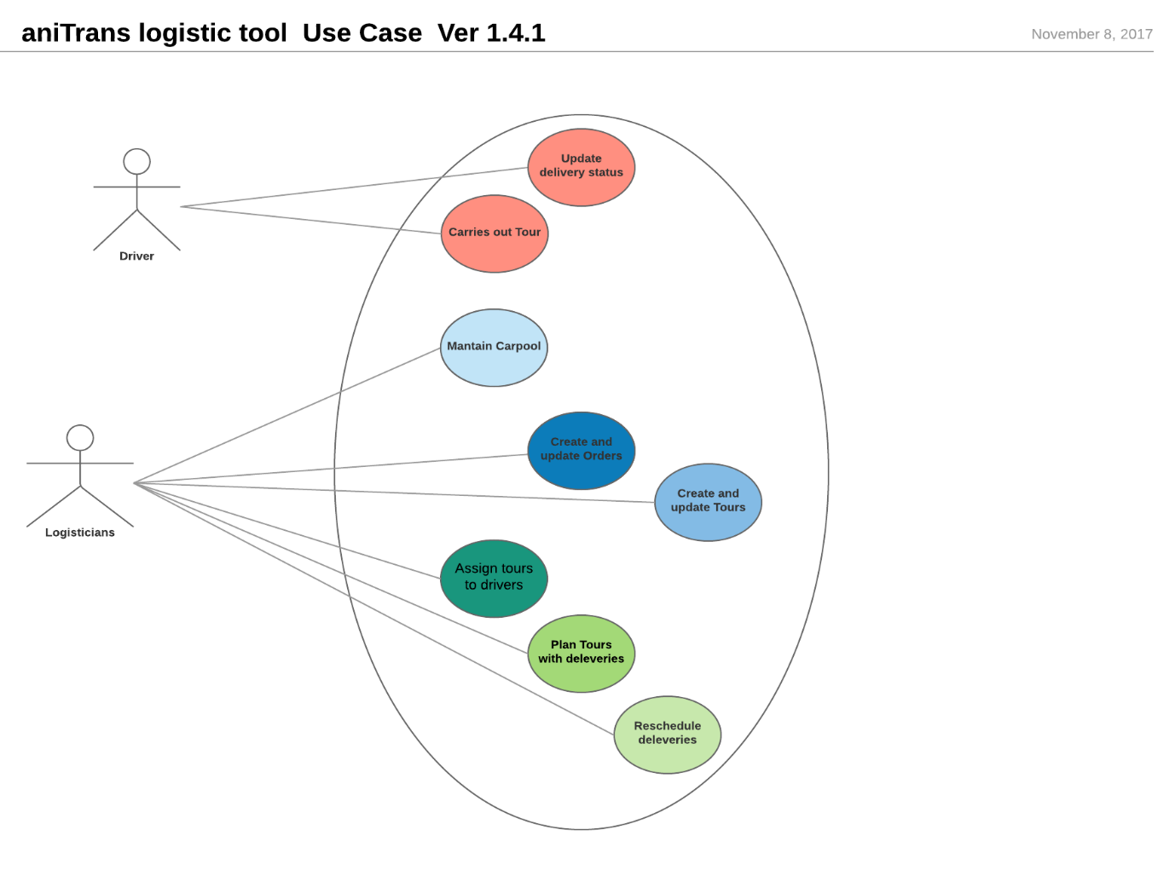

* + Logisticians
    - Log in
    - Plan tours
    - See which deliveries were delivered and which were not
    - Assign tours to drivers
    - Add and remove vehicles or vehicle types
    - View and delete drivers
  + Drivers
    - Create an account and log in.
    - See the tours incl. google maps and change the status of tours
    - Add comments to tours
  + Regular users
    - View homepage
    - Register

## 2.4 User Characteristics

General Preconditions

User has access to the internet and a working computer or smartphone.

User Characteristics

**Standard Users**: Ability to read English, able to register an account, able to navigate web-pages.

**Logisticians**: In addition to Standard User capabilities, they need to fill out forms, and manage a database through the graphical interface of the website.

**Driver** (standard) **Use Cases**

**Description**: Can see order-specific data, and can change the status of these orders.  
Cannot see Orders, Vehicles or Drivers pages.

**Pre-condition**: Should be logged in as a driver.

**Post-condition**: Order status changed.

**Main scenario**:

* Logs in.
* Navigates to tours.
* Reads tour information and carries it out.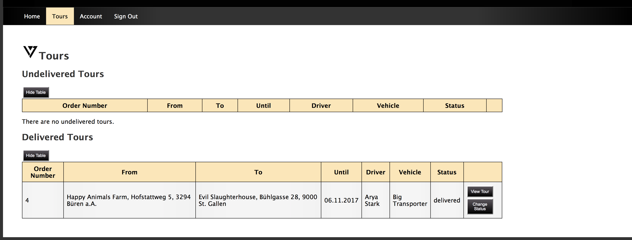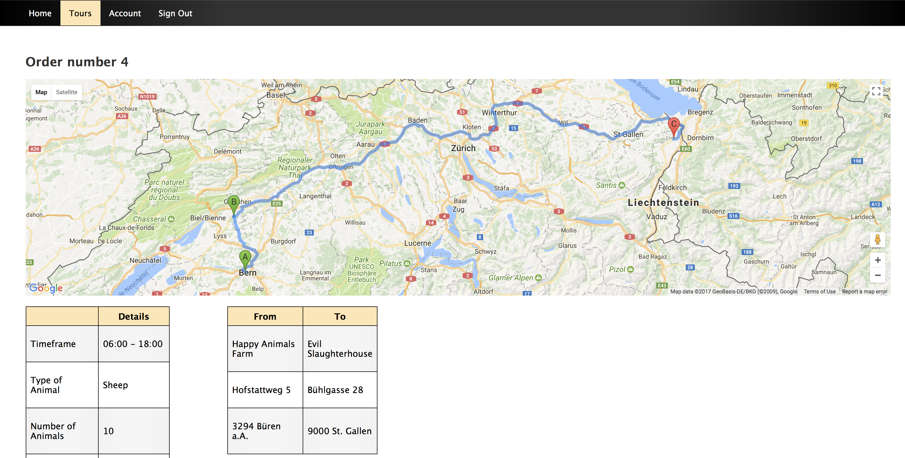
* Depending on if the animals are delivered or not, updates the status to „delivered“ or „undelivered“.

**Logistician Use Cases:**

**Description**: Can create orders and fill out required fields.

Can save orders and look into status changes made by drivers.

Can also delete orders, see and delete users, and see, add and delete vehicles

**Pre-condition**: Logged in as logistician.

**Post-condition**: New orders made, orders deleted, completed orders confirmed.

**Main scenario**:

* Navigates to Orders.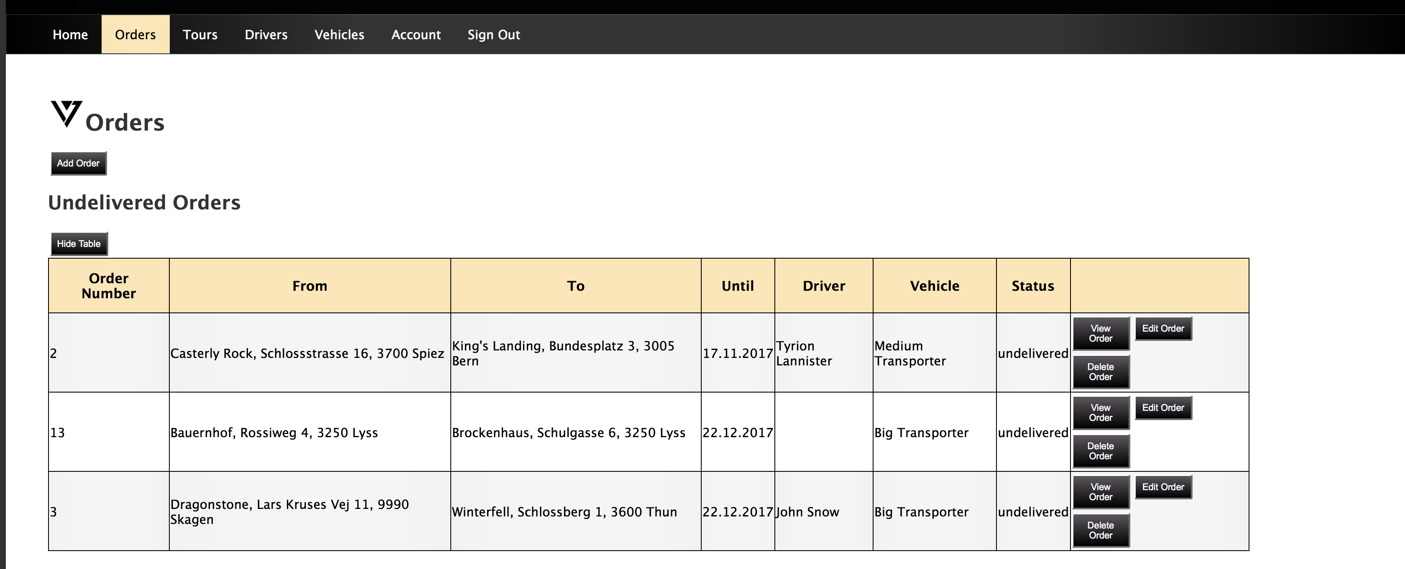
* Sees a list of pending orders as well as a create new order tab.
* If new order tab is selected, an empty form is displayed.
* If the form is filled out and confirm is clicked at the end, the order is saved and made visible for the drivers.
* 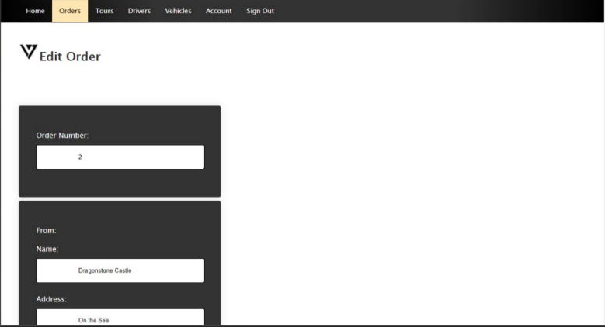Makes changes to existing orders.
* Sees and deletes users.
* See, adds and deletes vehicles.

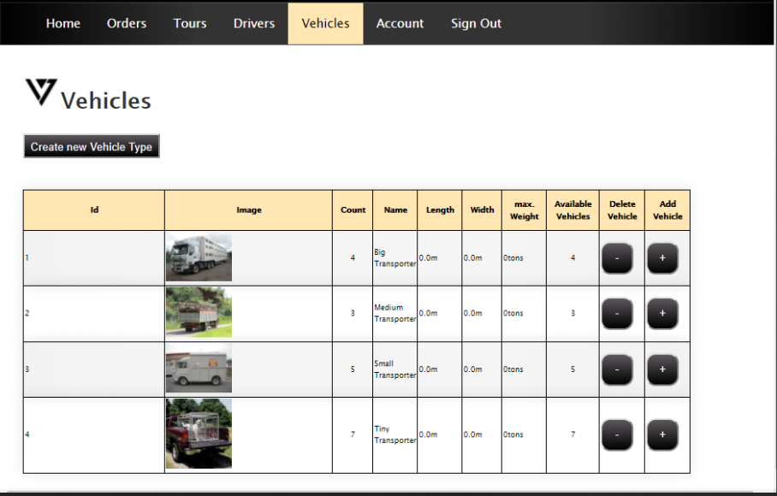

**Non-registered User Use Cases:**

User is unable to see orders, users, vehicles and drivers. The tabs are hidden for him or her.

User can see the homepage to get information about aniTrans.

User can register in the login tab.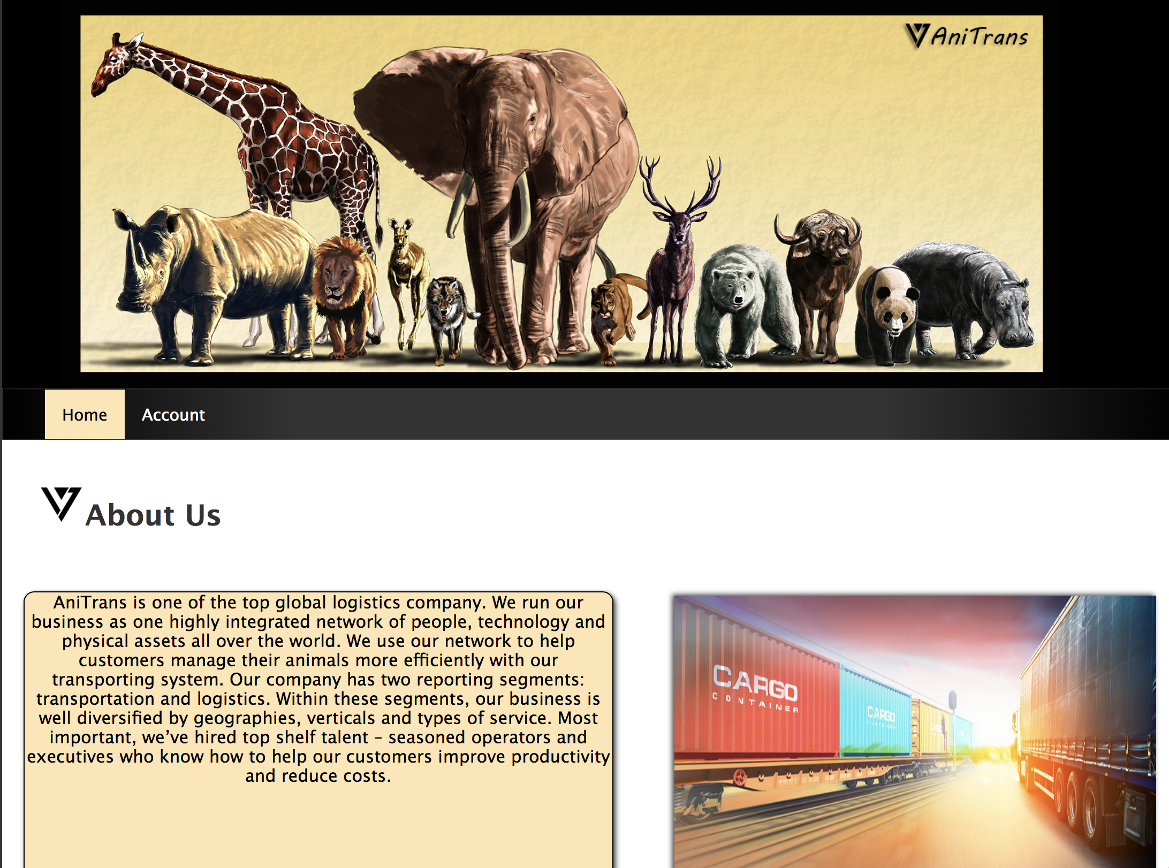

## 2.5 Constraints assumptions and dependencies

Version 1

* The product shall prevent incorrect data from being introduced.
* The product shall not be offensive to religious or ethnic groups
* The product shall make all functionality available to the managing director.

Version 2

* The product shall protect itself from intentional abuse.
* The product shall make its user aware of its information practices before collecting data from them.
* The product shall comply with logistics industry standards**.**

Out of scope

* The product shall be able to distinguish between French, Italian and British road numbering systems.

# 3. Specific requirements

## 3.1 External Interface Requirements

The application runs inside a browser. It should work with any browser but has only been tested it in Safari, Firefox and Google Chrome so far.

## 3.2 Functional Requirements

* Adding/deleting/editing/viewing orders with the specified attributes (from, to, until, timeframe, type of animal, number of animals, time estimation, start time, driver, vehicle, status, status message) (only visible to admin).
* Viewing orders and changing their status (visible to drivers and admin).
* Viewing drivers/users (just visible to the admin).
* Viewing vehicles, adding vehicle types and adding/removing single vehicle (only visible to the admin).
* Version 2: multiple trucks may be added to an order.
* Registering, login and logout (visible to anyone).
* Accessing the homepage (visible to anyone).
* Google Maps will be automatically generated with the tours address inputs. But the aniTrans HQ is fixed value in it the rest is dynamic (visible to driver and admin)

# 4. Non-Functional Requirements

## 4.0 User Interface

* The user interface of the system should be designed in a way to make the systems functions accessible to most users without prior learning or training.
* The user interface should be intuitive and easy to use.
* The language of the frontend is English
* The user interface is mobile responsive meaning its fits into different screen sizes and zooms.

## 4.1 Performance Requirements

The performance is good enough to make the response time acceptable to the user.

## 4.2 Logical Database Requirements

* The order table contains addresses (this is a foreign key relationship).
* The order table contains drivers and vehicles, but this is not a foreign key relationship, because we want the name of the driver/vehicle to stay even if the driver/vehicle is deleted. That way the user can see who the order was assigned to before that person was fired.
* The NewOrder, EditedOrder and NewUser tables never contain any entries. They only exist because their respective objects are used to transfer data from the html forms to the Java code. This is done because in the form the elements of an address (name, street, zip-code and town) are all single variables, whereas in the database it’s one Address object. The java code then converts the NewOrder, EditedOrder and NewUser objects into AniOrder, User and Address objects.

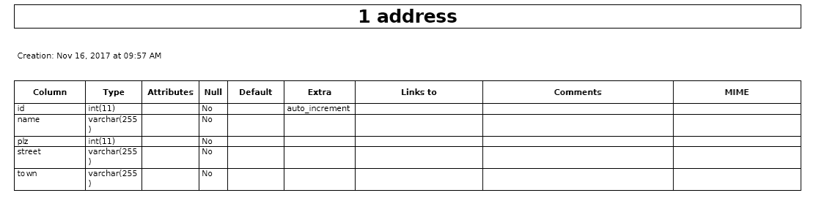

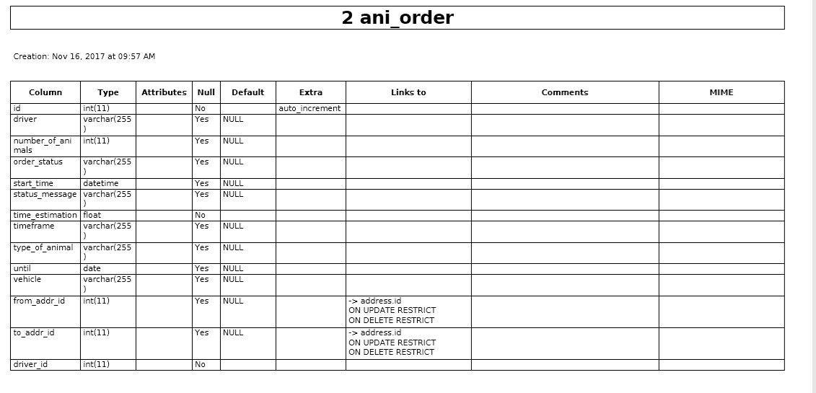

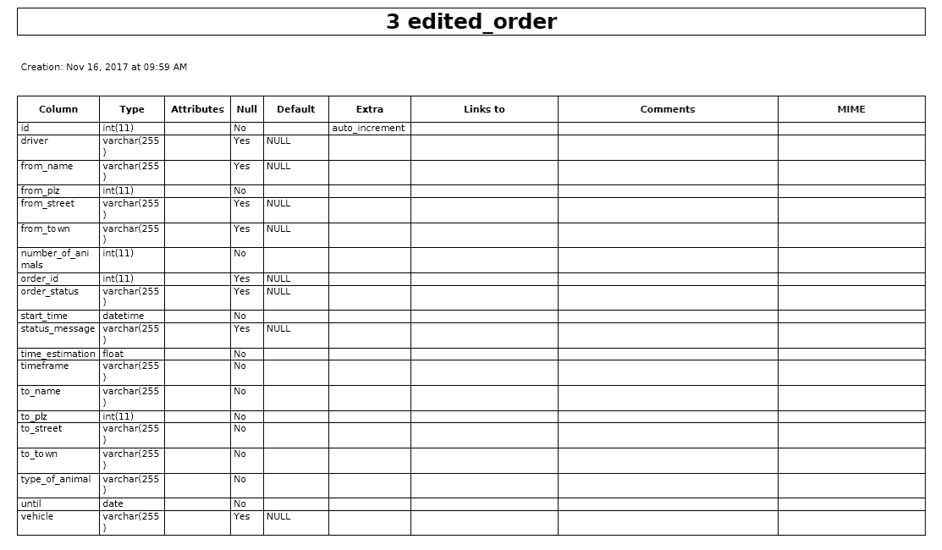

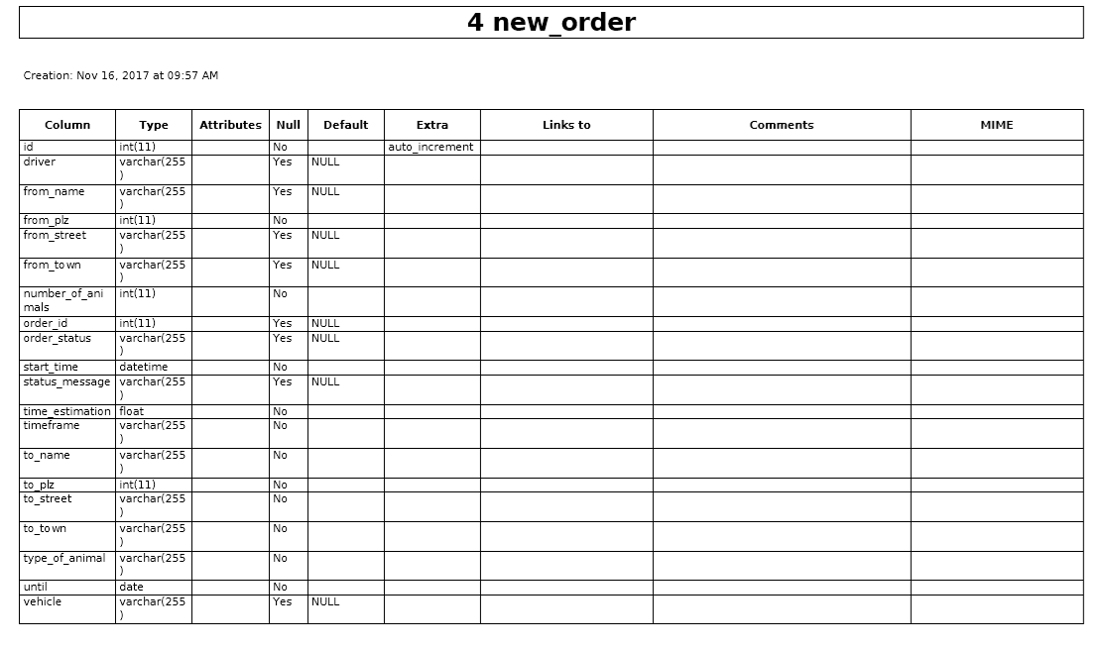

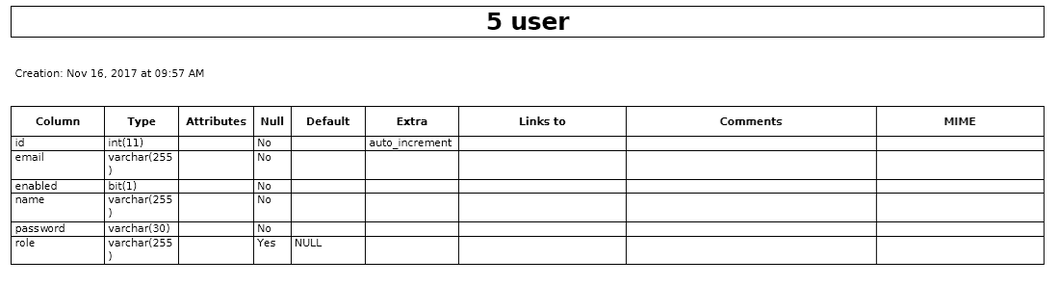

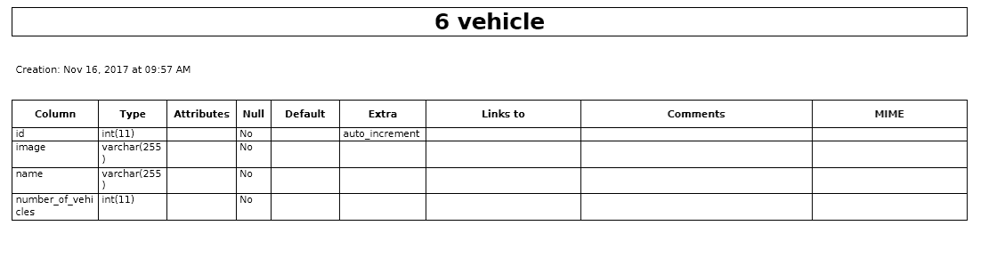

## 4.3 Software System Attributes

## 4.3.2 Availability

*.* Version 1

* There’s a working internet connection and the server is up and running.
* The product shall be available for use between the hours of 8:00am and 5:30pm
* The product shall be capable of processing up 50 customers.
* uptime should be around 95% availability

Version 2

* The product shall continue to operate in local mode whenever it loses its link to the central server
* The product shall be capable of processing up to 500 within three years.

### 4.3.3 Security

* The user data is kept as securely as necessary. Especially the password is stored securely (using the [BCrypt](http://en.wikipedia.org/wiki/Bcrypt)BCryptPasswordEncoder from the Spring Framework, a hashing algorithm with randomly generated salt).

### 4.3.4 Maintainability

Version 1

* The product is expected to run under Windows 10 and macOS High Sierra.

Version 2

* The maintenance releases will be offered to end-users once a year. The updates must be delivered to the server where the app itself is running. Same for the database. The App can only be updated after it has been shut down.
* Every registered user will have access to a help site via the Internet.
* The product shall be able to be installed in the specified environment within 2 working days.
* The App is extendable with new features which can be pushed out as updates.

Out of Scope

* The product might eventually be sold to a foreign market.

### 4.3.5 Portability

* The application should run stable on the browsers Microsoft Edge and Apple Safari 11.0.
* The application should run stable on major OS systems (Windows 10.0, macOS High Sierra).

### 4.3.6 Usability

Version 1

* The product shall help the user to avoid making mistakes
* The product shall make the users want to use it.
* The product shall be used by people with no training
* The product shall be easy for a truck driver to learn.
* The product shall use symbols and words that are naturally understandable by the user community.

Version 2

* The product shall conform to the Swiss Disabilities Act.
* The product shall allow the user to select a chosen language. Must be implemented in a separate sprint.